

Newsletter

Telephone: 8088 1244 Fax: 8088 5560

**Term One**

**Week Seven**

**9th March 2014**

Special Events

* New artificial turf will soon arrive for the transition room outdoor play area at Alma. Please stay tuned for information about which Wednesday we will stay a Bugdlie.
* A new shirt order will be made soon. More information will be in the next newsletter
* Harmony Day 20th March
* Look out for fee invoices coming soon. They will be delivered to you at Bugdlie

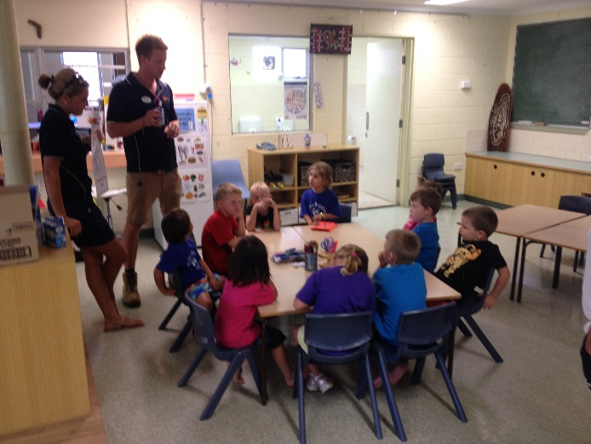

**Ash, from Maari Ma, started his nutrition program with the students.**

At Alma Bugdlie Preschool, the children have been learning about healthy eating. They have been quick to familiarise themselves with the healthy food plate and are very eager to identify “*sometimes” foods*. As a group, we cross referenced everyone’s lunch box contents with the plate. We were able to give lots of high fives to the healthy foods that have been packed. There have been some amazing conversations during lunch times and the children have encouraged each other not to eat their “*sometimes” food*. We were also very lucky to have Ash from Maari Ma begin his nutrition program. This term we will be exploring dairy food and its ability to make our teeth and bones strong.

Healthy Eating Habits

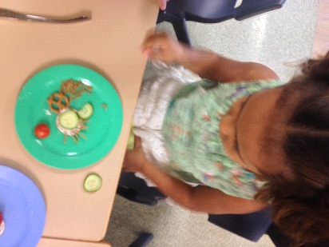

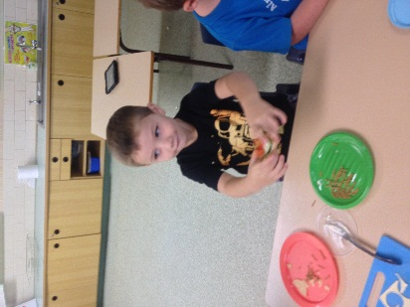

To Do

* If you are later than 2.50pm picking up your child on a Wednesday, please understand that we will be waiting for you in the Alma school office. The office is located at the other end of the school from our Preschool Transition Room.
* Information about reading food labels has been added to this edition of the newsletter along with some suggestions from the National Heart Foundation for healthy snacks.

**We would greatly appreciated donations of:**

* **Liquid Hand Soap**
* **SPF30+ Sunscreen**
* **Boxes of Tissues**
* **Glue Sticks**
* **Your time! Come and join us for activities at Bugdlie Preschool.**

**Just a reminder that we are a NUT FREE ZONE**

**National Heart Foundation Healthy Tick Approved Snack Foods**



**On the go or in the lunchbox**

Here are some ideas from the National Heart Foundation of healthy snacks to pack in your child’s lunchbox…

• Individual tubs of fruit in 100% natural juice

• Tick approved cereal bars (download our Tick shopping list)

• Air popped popcorn mixed with dried fruit packed in an air-tight container

• Slice of fruit loaf spread with margarine

• Individual low fat yoghurt pots

• Boiled egg

• Bananas

• Dried fruit medley (limit this snack to no more than once a day)

• Raw fruit and vegetables (1 serve is equivalent to 1 banana, 2 small plums or 1 carrot)

• 1 serving of Tick approved yoghurt

• Tick approved crackers (refer to pack for serving size) with ½ a sliced tomato and ¼ of a fresh avocado For more tasty, healthier recipes, visit

**heartfoundation.org.au/recipes**

**National Heart Foundation Healthy Tick Approved Shopping List**

There are many healthy snack options listed on the National Heart Foundations Healthy Tick Shopping list. This can be found at the following web address:

<http://www.heartfoundation.org.au/SiteCollectionDocuments/Tick_Shopping_List.pdf>

All fresh fruit and vegetables are automatically eligible for the Tick.

We have used this information to make the list of healthy snacks below for your convenience.

**Cereal based bars**

Be Natural

Trail Bars Honey Nut (6x32g)

Trail Bars Nut & Fruit (6x32g)

Trail Bars Berry (6x32g)

Kellogg’s

K-time Twists Raspberry & Apple

(5x37g)

K-time Twists Strawberry &

Blueberry (5x37g) or (9x37g)

K-time Twists Strawberry &

Yoghurt Flavour (5x37g)

Tasti Mookies

Choc Vanilla (10 pk) 200g

Choc Strawberry 10 Pack 200g

Uncle Tobys

Bodywise Bars Apple Delight

**Cheese**

Bega Country Light Vintage

25% Less/Fat Cheese Block

Bega So Light

25% Red/Fat Cheese Block

Bega So Light Extra

50% Red/Fat Cheese Block 500g

50% Red/Fat Cheese Shredded

50% Red/Fat Cheese Slices

Coles

Australian Tasty Light Cheese

Shredded

Australian Mozzarella Light

Cheese Shredded

Australian Tasty Light Cheese

Coles Simply Less

Extra Lite Spreadable Cream Cheese

Light Cottage Cheese Original

Light Cottage Cheese with

Pineapple

Light Cottage Cheese with

Onion & Chives

Dairy Farmers

Low Fat Cottage Cheese (plain)

Kraft

Philadelphia Extra Light Mini Tub

Pantalica

Light Ricotta Cheese

Perfect Italiano

Light Ricotta

**Yoghurt**

Vanilla Yoghurt Thick & Creamy 1 kg

Summer Berry Yoghurt Thick & Creamy

Peach & Mango Yoghurt Thick & Creamy 1 kg

Strawberry Yoghurt Thick & Creamy

Berry Basket Yoghurt (2 x Strawberry;

2 x Summer Berry;2 x Blueberry) 6x175g

**Coles Simply Less**

**Light Pouring Custard Vanilla**

**Flavoured 600g**

**Tropical Yoghurt (2xTropical**

**Fruits; 2 x Mango;**

**2xPassionfruit) 6 x 175g**

**Mango Yoghurt 170g**

**Rhubarb & Vanilla Bean Yoghurt 170g**

**Lemon Cheesecake Flavoured Yoghurt**

**Raspberry Yoghurt 170g**

Diet Deli Yoghurt Greek Natural 380g

Diet Deli Yoghurt Passionfruit 380g

Diet Deli Yoghurt Raspberry 380g, 550g

Thick & Creamy Yogurt Citrus Cheese Cake Flavour 180g, 550g

Thick & Creamy Yogurt Honey 180g,

Thick & Creamy Yogurt Strawberry

Thick & Creamy Yoghurt Pomegranate

Thick & Creamy Yoghurt Peach & Mango 550g

Thick & Creamy Yoghurt Peach & Pear

Thick & Creamy Yogurt Vanilla

Thick & Creamy Yoghurt Peach & Raspberry

Dairy Farmers

Pouring Custard Vanilla 500g, 1kg

**Dried fruit**

Australian currants 300g

Australian raisins 375g

Australian sultanas 375g,

Dried Apricots 200g, 650g

Sultana & Apple Snack Pack 25g

Australian Sultana Snack Pack 40g

Sultana & Apricot Snack Pack 37g

**Canned fruit**

Australian unsweetened pineapple crushed in juice 440g

Australian unsweetened pineapple pieces in Juice 440g, 825g

Australian unsweetened pineapple slices in juice 440g,

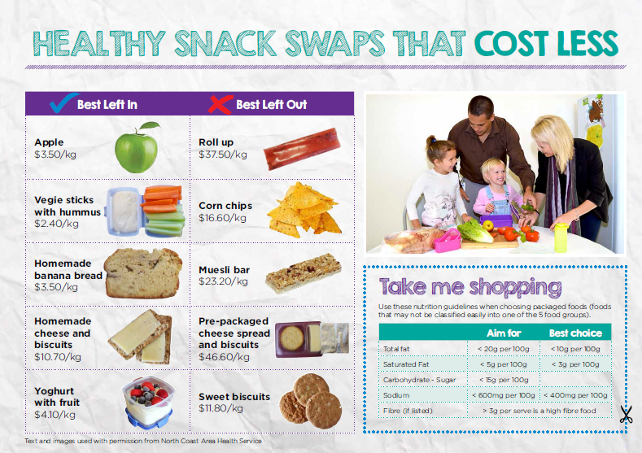

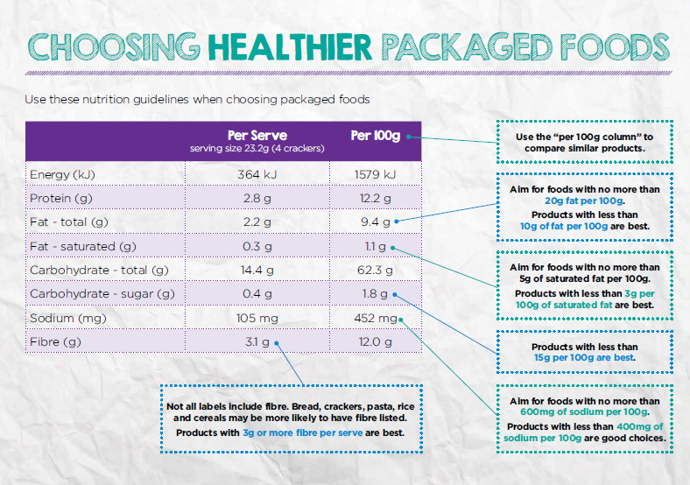

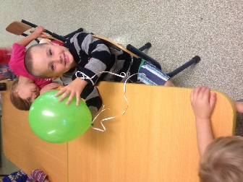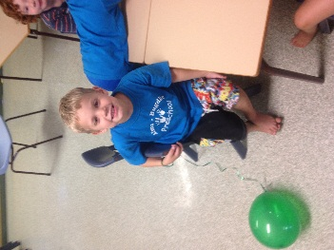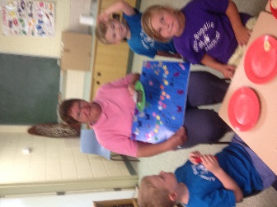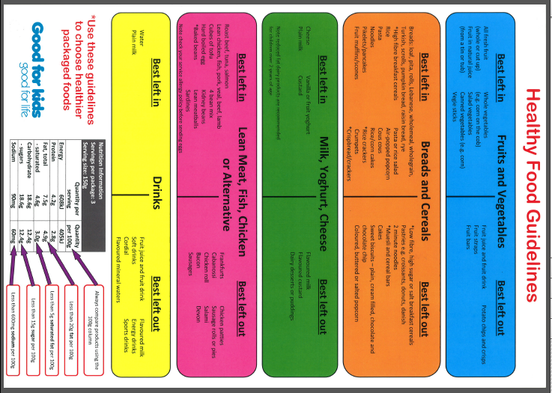

Happy Birthday to Aunty Barb, Bryce and Tyson