

Telephone: 8088 1244 23 February, 2015 Fax: 8088 5560

Special Events

On Monday 16th Ash, from Maari Ma, came to visit. He started his nutrition program with the students. We learnt that milk and other dairy foods make our bones and teeth strong. This experience was repeated on Friday.

* Fees due week 8. More information coming soon.
* Alma Days are every second week with Session One (Thalta) Wednesday 25th and Session 2 (Kulthi) Wednesday 4th March

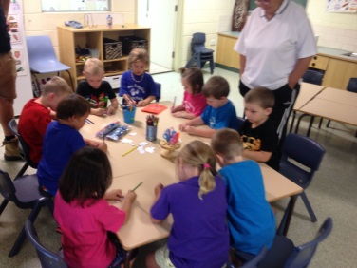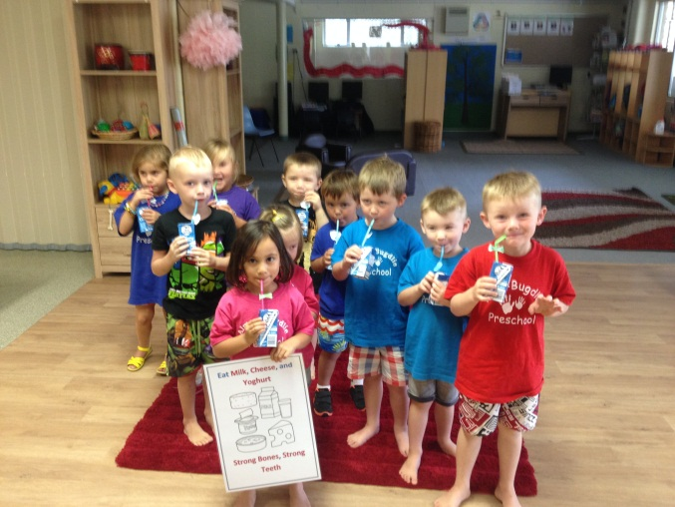

**Term One**

**Week Five**

**23rd February 2014**

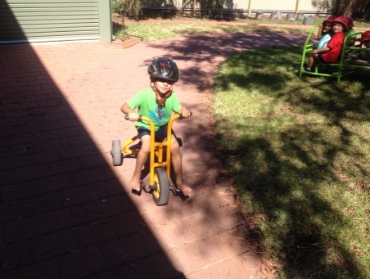

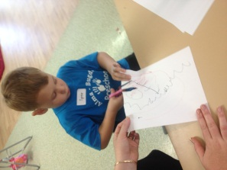

**We begin this year with Mrs Katie Bassett-White, as the Assistant Principal, responsible for the Alma Bugdlie Preschool and all team members.**

**We welcome back Aunty Barb, our Aboriginal Education Officer and Chelcie Staker, our Student Learning Support Officer.**

**Mrs Gemma Ackerman joins us once again as a Preschool Teacher.**

**We also welcome back Mrs Christy Roe as our Preschool Teacher every Tuesday and Thursday morning.**

**Stacey Smith is a new addition the Bugdlie team for 2015. Stacey will be working with us on volunteer basis every Friday.**

Bugdlie 2015

Class of 2015

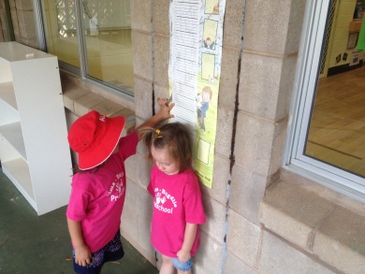

*Bugdlie T-shirts $15 a shirt or 3 for $40*

*The colder weather has set in, so also check out our Jumpers $20 each Jumper*

Things To Do for Preschool

* Please ensure all your child’s belongings have their name clearly printed on them.
* Remember to sign your child in and out everyday.
* Each day, place one piece of fruit in our fruit bowl. It will be your child’s contribution to the children’s morning fruit platter.
* Pack a healthy lunch and a bottle of water lunch boxes so far have been fantastic!!!).



Preschool Opening Hours

8.45am -2.45pm



**Just a reminder that we are a NUT FREE ZONE**

**Beginning Preschool**

For many children, childcare is their first experience of extended separation from their parents and for many parents the guilt they have about leaving their child can make the first few days of childcare an emotional time.

A little preparation can go a long way towards decreasing the anxiety felt by both children and parents as your family becomes accustomed to the new arrangement.

The First Few Days…

• Remember that it is perfectly normal for children to be teary and emotional on the first few drop-offs.

• Try and adopt a calm, positive attitude. Children have a remarkable ability for sensing the mood of their parents and ensuring you maintain a façade of confidence will instil confidence in your child.

• Say a quick good bye give your child a kiss and cuddle and then leave, prolonged farewells will simply draw out the tears.

• Whatever you do, don't sneak out, as this will make the child mistrustful and clingier the next day.

• Once you have left the Bugdlie team will engage your child in an interesting activity, so try not to worry!

• Remember you can call at any time during the day if you feel concerned, so feel free to pick up the phone if you need some reassurance.

• On pick up ask the educator for a quick debrief on how the day went, discuss any concerns you had, how your child managed, what they enjoyed and so on. Learning about your child's day will help you feel involved, even if you can't be around to participate.

• Maintain the positive chats and stories with your child at home so preschool

becomes something to look forward to and enjoy rather than something to dread.

• If your child continues to be teary and emotional, encourage them to talk about their feelings, validate those feelings, and then positively reiterate why care is necessary.

Remember, some children adapt more quickly to preschool than others and the transition period will be different for all children. Please come and talk to your child’s educators if you have any concerns.

